Hi all

As mentioned in meeting today, the following are the practice assignments to be presented for next meeting for **Cherry, Stephen, Steven, and Andy**. Can discuss with each other but put in individual efforts so that all of you learn. Show your simulation results. You can work together for Questions 7 to 12.

1*.****ALL:****Write out the ODEs from the attached LasR model script, and draw the schematics of the model using SBOL visual symbols (http://sbolstandard.org/visual/).*

circuitODE[0] = (0.0 - (0*y[0]) **inducer_AHL**

circuitODE[1] = 0.062233 - (0.0058*y[1]) **mRNA_pTetR**

circuitODE[2] = (0.595*y[1]) - (0.00116*y[2]) **peptide_RBS1**

circuitODE[3] = (0.0+((6.817e-08*(y[5]**2))/(7.702e-05**2+y[5]**2))) - (0.0058*y[3]) **mRNA_pLasR**

circuitODE[4] = (0.1785*y[3]) - (0.0061*y[4]) **peptide_RBS2**

circuitODE[5] = (16000*y[0]*y[2]) - (0*y[5]) **interaction_LasR_AHL**

y[0] = 1e-09 # [inducer_AHL]

y[1] = 1e-06 # [mRNA_pTetR]

y[2] = 1e-06 # [peptide_RBS1]

y[3] = 0.0 # [mRNA_pLasR]

y[4] = 0.0 # [peptide_RBS2]

y[5] = 0.0 # [interaction_LasR_AHL]

*2.       Cherry and Stephen: From LasR model, I want to increase GFP production. Should I change the RBS driving LasR protein or the RBS driving GFP (thereby, varying the RBS strength)? Explain with simulation results.*

*3.****Stephen and Steven:****What will happen to LasR and GFP output if AHL is unstable and degrades at the same rate as mRNA?*

Original value

GFP: 0.000343836803316

LasR: 4651.18198256

Unstable AHL(inducer)

GFP: 0.000343836 (increased)

LasR: 4651.18198256

*4.****Steven and Andy:****What will happen to LasR and GFP output if AHL is constantly increasing (hint: you need to modify the ODEs)? What does this mean in experimental context?*

GFP: 0.000343842 (increased)

LasR:4651.18198256

This shows that the AHL does not affect the production of LasR.

5.       **ALL:** How to change the model so that LasR is now IPTG inducible?

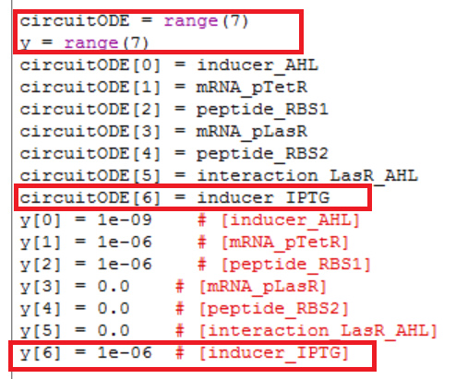

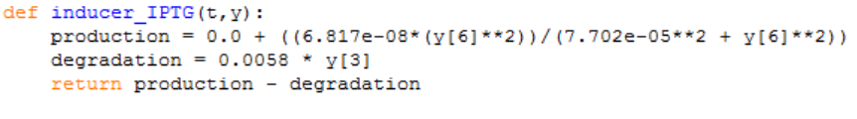

*6.****ALL:****How will GFP level differ at steady state when you vary [IPTG] and [AHL] (hint: You need a 3-D graph)? Is steady-state achieved within the same duration?[dont know]*

*7.       Hexokinase metabolizes glucose into gluose-6-phosphate in a non-reversible fashion. Write the ODEs for this model, implement and simulate the model.[done]*

*8.       How will increasing the level of hexokinase affect gluose-6-phosphate production rate?[done]*

By increasing the level of hexokinase will also increase the rate of glucose-6-phosphate production.

*9.       Phosphoglucoisomerase catalyzes gluose-6-phosphate to fructose-6-phosphate in a reversible fashion. Extend the model from Question 7 and simulate. [done]*

*10.   Phosphofructokinase catalyzes fructose-6-phosphate to fructose-1,6-bisphosphate in a non-reversible fashion. Extend the model from Question 9 and simulate.*

*11.   Fructose phosphate aldolase catalyzes fructose-1,6-bisphosphate to glyceraldehyde-3-phosphate and dihydroxyacetone phosphate in a reversible fashion. Extend the model from Question 10 and simulate.*

*12.   Actually, glucose-6-phosphate is also the substrate for glucose-6-phosphate dehydrogenase, which forms 6-phosphogluconolactone as the first step of Pentose Phosphate Pathway. Modify the model from Question 11, simulate and how will the steady-state concentration of dihydroxyacetone change as a result of this branching?*